15th SKIF WORLD CHAMPIONSHIPS
November 09-15, 2026
Granada Luxury Belek Hotel, Antalya I Türkiye

All-Inclusive Athlete Package Form
Beyond Accommodation: Everything You Need in One Package

Please return the completed form, together with credit card details or one night deposit of the accommodation, to Local Organizing Secretariat Serenas International Tourism at e-mail: skif2026@serenas.com.tr at latest by June 01st. 2026

PERSONAL DETAILS : ....... Women ....... Men ....... Senior ....... Junior

Name of Member Association/Federation
Country
Contact Name
Telephone
Address
City / Country
E-mail
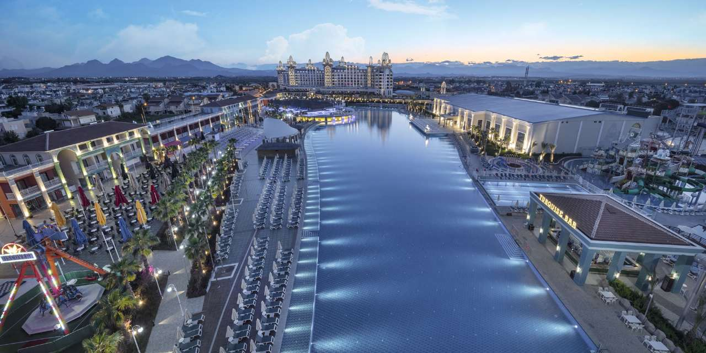
Photo: Granada Luxury Belek Hotel, Antalya I Türkiye (Championship Venue / Official Hotel)

“ALL-INCLUSIVE ATHLETE PACKAGE” FEES
Accommodation, Training & Airport Transfers — All Included in One Price
📍 Granada Luxury Belek Hotel 5 / Official Championship Venue & Hotel

No of  nights | Single Room | Double Room  (2 pax in the room) | Triple Room  (3 pax in the room) | Quadruple Room  (max 4 pax in the room)
4 nights | Single Room  4 nights: EUR 1.390 | Double Room / 4 nights  in per person EUR 830  Room Fee: EUR 1.660 | Triple Room / 4 nights  in per person EUR 750  Room Fee: EUR 2.250 | Quad Room / 4 nights  in per person EUR 710  Room Fee: EUR 2.840
5 nights | Single Room  5 nights: EUR 1.725 | Double Room / 5 nights  in per person EUR 1.025  Room Fee: EUR 2.050 | Triple Room / 5 nights  in per person EUR 925  Room Fee: EUR 2.775 | Quad Room / 5 nights  in per person EUR 875  Room Fee: EUR 3.500
6 nights | Single Room  6 nights: EUR 2.060 | Double Room/ 6 nights  in per person EUR 1.220  Room Fee: EUR 2.440 | Triple Room/ 6 nights  in per person EUR 1.100  Room Fee: EUR 3.300 | Quad Room / 6 nights  in per person EUR 1.040  Room Fee: EUR 4.160
7 nights | Single Room  7 nights: EUR 2.395 | Double Room / 7 nights  in per person EUR 1.415  Room Fee: EUR 2.830 | Triple Room / 7 nights  in per person EUR 1.275  Room Fee: EUR 3.825 | Quad Room / 7 nights  in per person EUR 1.205  Room Fee: EUR 4.820
8 nights | Single Room  8 nights: EUR 2.730 | Double Room / 8 nights  in per person EUR 1.610  Room Fee: EUR 3.220 | Triple Room/ 8 nights  in per person EUR 1.450  Room Fee: EUR 4.350 | Quad Room / 8 nights  in per person EUR 1.370  Room Fee: EUR 5.480
- The room rates are in Euro (€). The package rates are per room, per person.
- Granada Luxury Resort is the championship venue and training site will be available in the same complex.
- Countries that have finalized their package accommodation at the championship hotel will not be charged any additional fees for the use of the training hall or similar facilities. Once these countries send their training hall requests in writing, including their preferred date and time, to skif2026@serenas.com.tr scheduling will be arranged accordingly.

Package Fees Includes:
- Ultra-All-Inclusive Basis accommodation basis at Granada Hotel (Championship Venue). *Ultra-All-Inclusive Basis Concept
- The Antalya International Airport – Granada Luxury Hotel (Championship Venue) – The Antalya International Airport roundtrip transfers. (The distance is 42 km.)
- The use of the training field by countries that have purchased the accommodation package without any additional charge.
- An internet access at the Granada Hotel (Championship Venue). Service charge and 10 % VAT and 2 % accommodation tax.

*Ultra-All-Inclusive Basis Concept at the Granada Luxury Belek Resort:
Service | Pricing | Hours
Breakfast / Open Buffet | Free of charge  (Included to above accommodation package fees) | 07:00-10:00
Late Breakfast / Open Buffet |  | 10:00-11:00
Lunch / Open Buffet |  | 12:30-14:30
Dinner / Open Buffet |  | 18:30-21:00
Diet & Vegetarian Open Buffet |  | At breakfast, lunch and dinner
Snack Menu / Open Buffet |  | 12:30-16:00
Patisserie |  | 11:00-18:30
Night Meal / Open Buffet Style |  | 23:30-02:00
All local and some import drinks, hot and soft drinks, fruit juice |  | 09:00-24:00 &12:00-22:00
Beer and soft drinks |  | 16:00-07:00 & 23:00-02:00
Hot and soft drinks |  | 10:00-18:00
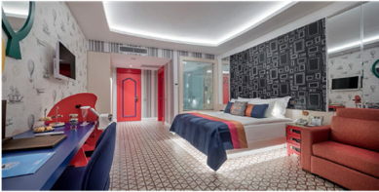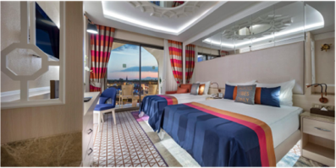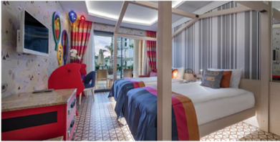
Single Room Double / Triple Room Family Room / Up Stairs & Down Stairs
Outside Participation Fee
Those who are not staying at the official hotel Granada Luxury Belek Resort by Local Organizing Secretariat Serenas International Tourism must pay Outside Participation Fee per day/per person to entrance to the Granada Championship Venue.

Outside Participation Fee 65 EUR / per person, per day
Outside Participation Fee includes:
- The entrance to the Granada Belek Championship Venue between hours on 09:00-18:00.
- Open Buffet Lunch and two coffee breaks with cookies at the Granada Belek Championship Venue.
- To reach an internet access the Granada Belek Championship Venue.
- Includes 20% VAT.

Confirmation, changes, cancellations and refunds:
- Reservation should be made before October 01st, 2026. Reservation after this date shall be subject to availability.
- The full payment for each room is required in order to confirm your hotel reservation.
- Payments can be conducted either by bank transfer or credit card. Travelers’ cheque will not be accepted.
- All cancellations must be made in writing and sending an e-mail to skif2026@serenas.com.tr
If received by October 15th, 2026 full refund of the deposit payment or full payment.
If received later than October 16th, 2026 there will be no refund.
Handling Fee: 50 € for per person (VAT is included) for each cancellation.
- All rates are subject to change without prior notice.
- All refunds, if any, will be processed in 15 days.
- Name change will be accepted up to 72 hours prior to the Championships.
- Changes in arrival or departure dates will be accepted with no extra charge, and subject to availability of rooms, up to 72 hours before the confirmed date of arrival. If advice of a delayed arrival date is received less than 72 hours before the previously confirmed date of arrival, one night’s fee will be charged.
- No refunds will be made no-shows.

ROOM RESERVATION / Please reserve the following:

No of _________SINGLE ROOM From_________ to___________ November 2026

No of _________DOUBLE ROOM From_________ to___________ November 2026

No of _________TRIPLE ROOM From_________ to___________ November 2026

No of _________QUADRUPLE ROOM From_________ to___________ November 2026

__________________ TOTAL ROOMS
We require facilities for the handicapped. Please indicate

BLOCK ROOM RESERVATIONS

I AM MAKING BLOCK BOOKING ON BEHALF OF _____________________ASSOCIATION/FEDERATION
(Fill in the form at the back of the sheet)

ROOM TYPE | NUMBER OF ROOMS | Night | PACKAGE RATE per person | TOTAL RATE
Single Room
Double Room
Triple Room
Quadruple Room
TOTAL AMOUNT FOR ROOM |  |  |  | EUR

FLIGHT DETAILS

Number of Person : ______________

Date of Arrival : Time : Flight :

Date of Departure : Time : Flight :

* Please send your flight details via e-mail to skif2026@serenas.com.tr
* For private transfers (individual or group) please contact Serenas Tourism (skif2026@serenas.com.tr)

METHOD OF PAYMENT (Please tick appropriate box)

Bank Transfer

Account Name: SERENAS ULUSLARARASI TURİZM KONGRE ORGANİZASYON A.Ş.
Bank Name: T. Garanti Bankası AŞ.
SWIFT Code: TGBATRISXXX
EFT Code: 62
Branch Name: Ankara Ticari Şb.
Branch Code: 170
Branch Address: Güvenevler Mah. Cinnah Cad. No:2 D:1, Çankaya, Ankara, Türkiye
TRY IBAN: TR65 0006 2000 3810 0006 2462 89
EUR IBAN: TR39 0006 2000 3810 0009 0440 43
Tax Office: Seğmenler
Tax Number: 7620276380

Credit Card
Please Charge Total Amount of EURO** from my credit card.

Visa Master Card CVV Code:

Cardholder’s Name:
Exp. Date: / / Signature:

Date of Signature: Signature:
Card No:

INVOICE ADDRESS:
Invoice Address:
TAX Office Name:
TAX Number:

FOR BLOCK ROOM BOOKINGS

Details of participants shall be completed and submitted to Local Organizing Secretariat Serenas International Tourism at

e-mail: skif2026@serenas.com.tr at latest by October 01st. 2026

 | NAME | SURNAME | ROOM  TYPE | ARRIVAL |  |  | DEPARTURE
 |  |  |  | DATE | FLIGHT | TIME | DATE | FLIGHT | TIME
1
2
3
4
5
6
7
8
9
10
11
12
13
14
15
16
17
18
19
20
21
22
23
24
25
26
27
28
29
30
31
32
33
34
35
36
37
38
39

